EXPERIMENT NO 1

AIM:TO DEVELOP AND DESGIGN A MOBILE OR WEB APPLICATION AND TO CHANGE THE BACKGROUND,MENU AND COLOR

PROCEDURE:

\*CREATE A WIREFRAME ACCORDING TO YOUR DESIGN.

\*SELECT THE THEME FOR YOUR DESIGN..

\*CHANGE THE BACKGROUND OF THE COMPLETED DESIGN

\*THE DESIGN OYOUR APPLICATION IS READY

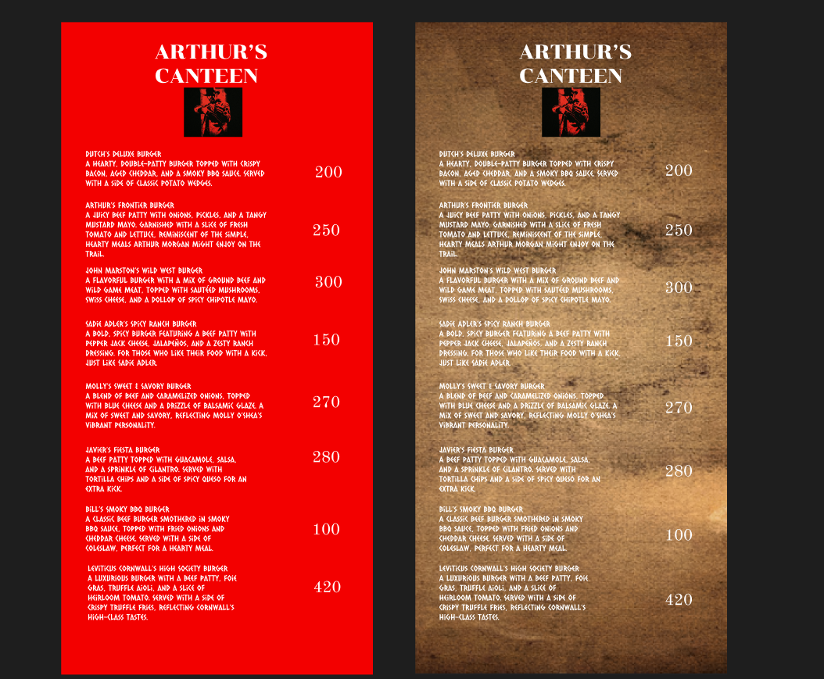

RESULT:

THE DESIGN WAS SUCESSFULLY CREATED